Notes from the ED – November 2023
I am back! Slimmer, fitter and despite Doctor’s order ready to run too! Many thanks to everyone who sent me their best wishes. The episode did reinforce to me that our health is of primary importance, both physical and mental, and that we should pay more attention to the warning signs that our bodies give us, rather than keep ploughing on. The Council is blessed with a good team of people, and I was particularly thankful for the support from Liyana and Jenn in covering for me when I was ill, and then for making sure that I was on light duty for a few weeks until I fully recovered.
We are now rapidly heading towards the end of the year, but work is already underway for 2024. The Council turns 10 next year, and we want to celebrate it with a bang! Our Gala Dinner and Business Summit will be held in April in Singapore, and we are looking for sponsors. Sponsorship packages can be found here and if you would like to be part of the Council’s Anniversary, please do not hesitate to reach out to me or my team.
Now back to November - several of our members joined me for a luncheon with European Commissioner Mairead McGuinness hosted by the EU Ambassador to Singapore, Iwona Piorko. Commissioner McGuiness was in Singapore for the FinTech events, but was very much in listening mode with us, wanting to know more about developments in financial services in Southeast Asia, green and sustainable finance developments, and the views of the ASEAN region on various EU policies.
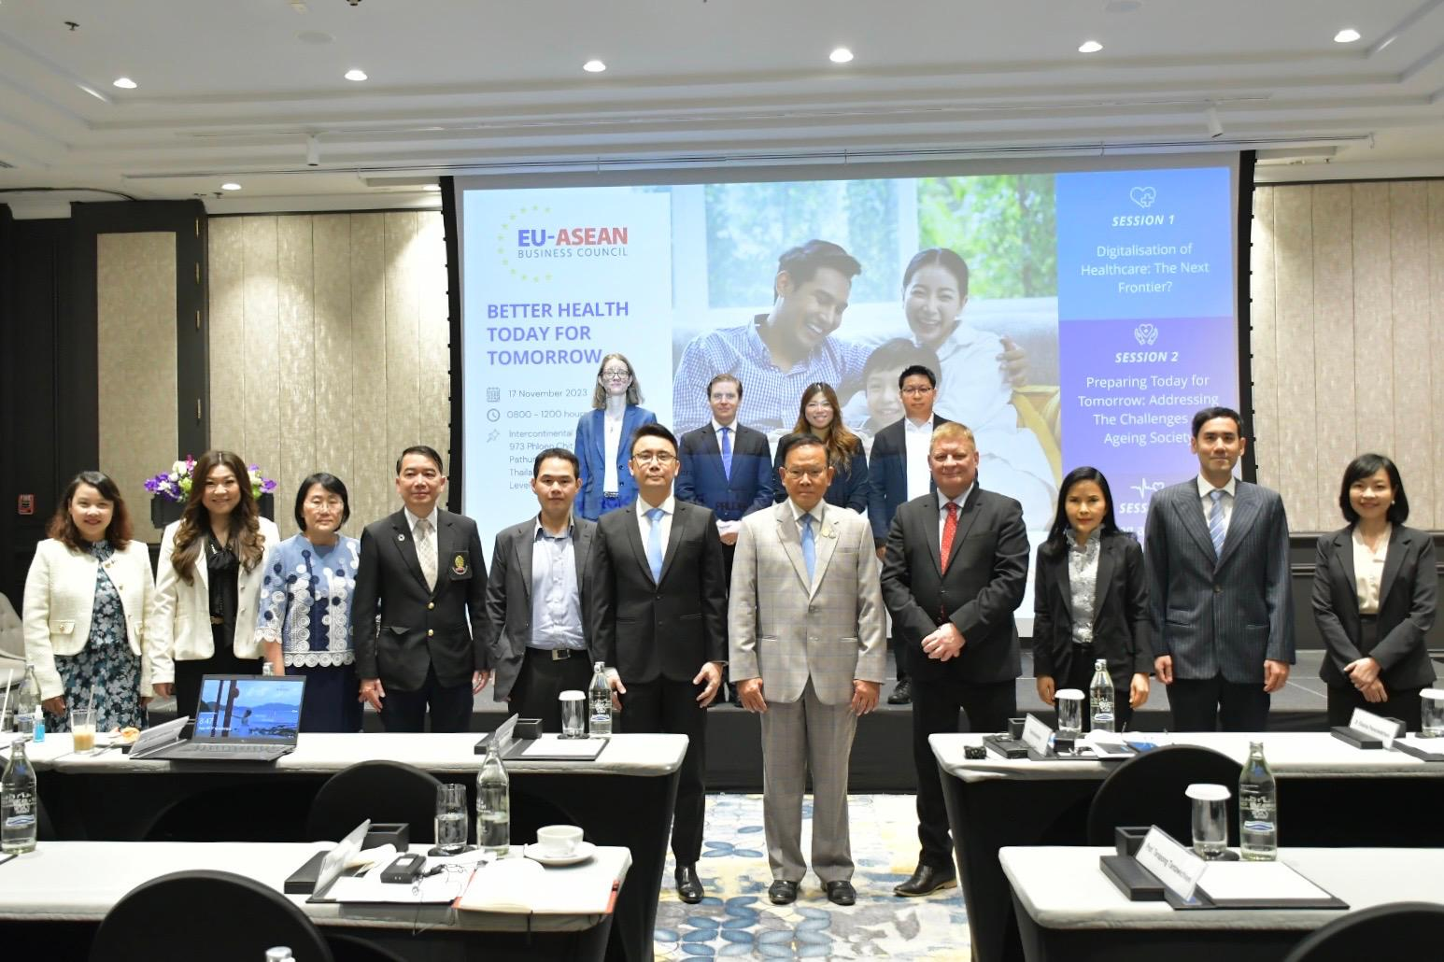
From that luncheon we were off to Bangkok for two events. The first was the last of our health roadshows for 2023, where we were blessed with Deputy Minister for Public Health, H.E. Santi Promphat, giving the opening keynote address at the start of proceedings before we moved in to three stimulating discussions on leveraging digital to make enhance accessibility of healthcare; encouraging individuals to age healthily and find strategies to boost the fertility rate in Thailand; before finally diving into the importance of sustainable healthcare financing. Many thanks to our members Zuellig Pharma, Prudential, Sanofi, Bayer and Merck for sponsoring and supporting this key event.
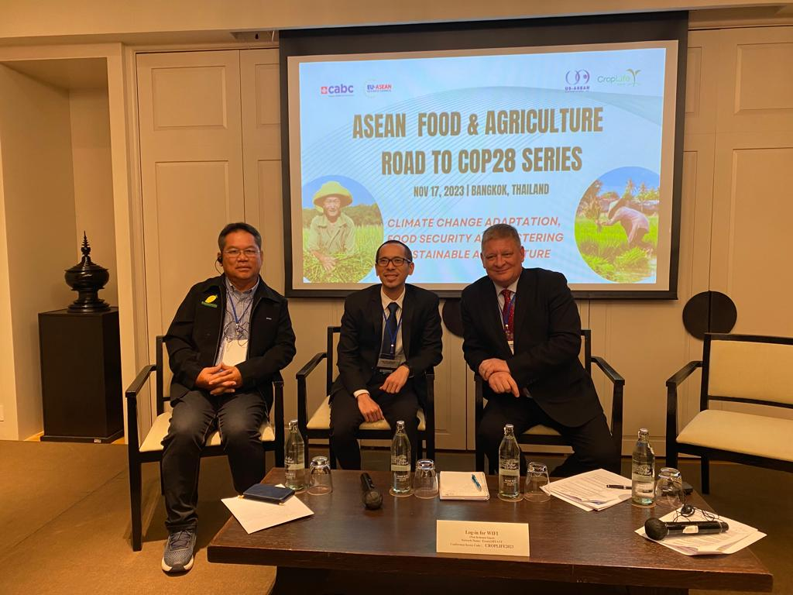
Following straight on for the health roadshow we rushed across the road for the next in our workshops with CropLife Asia, US-ASEAN Business Council and Canada-ASEAN Business Council looking at the key role that the Agricultural sector in ASEAN has to play in climate change and how the public and private sector need to work closer together to help mitigate the impacts of climate change on the sector, whilst also helping it to develop further, enhance farm outputs and rural incomes and lead to improvements in food security in the region. You can read more about this event (and subsequent we did on Vietnam later in the month) here.
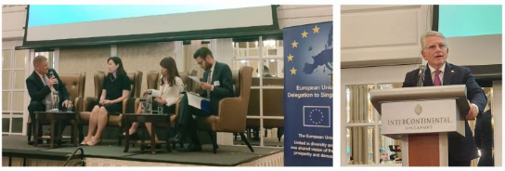
We were honoured to be the implementing partner for a seminar on the EU’s Carbon Border Adjustment Mechanism on 20th November, working with both DG TAXUD (who will be implementing the policy for the Commission) and the EU Delegation to Singapore. We had a full house of over 100 participants for two panel discussions on the topic and a keynote address from Director-General Thomas Gerassimos of DG TAXUD. There was an excellent discussion on the merits of CBAM and how it is to be implemented. This event followed a meeting earlier in the day between EU-ABC members and the Director General.
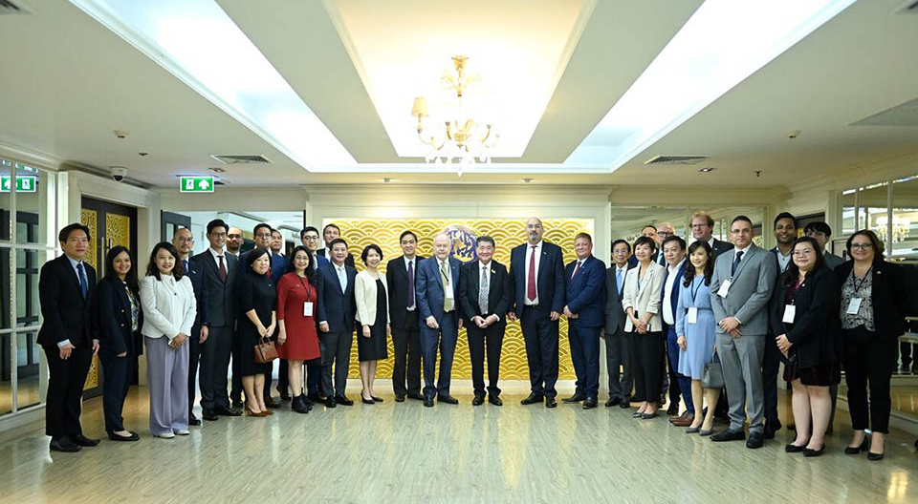
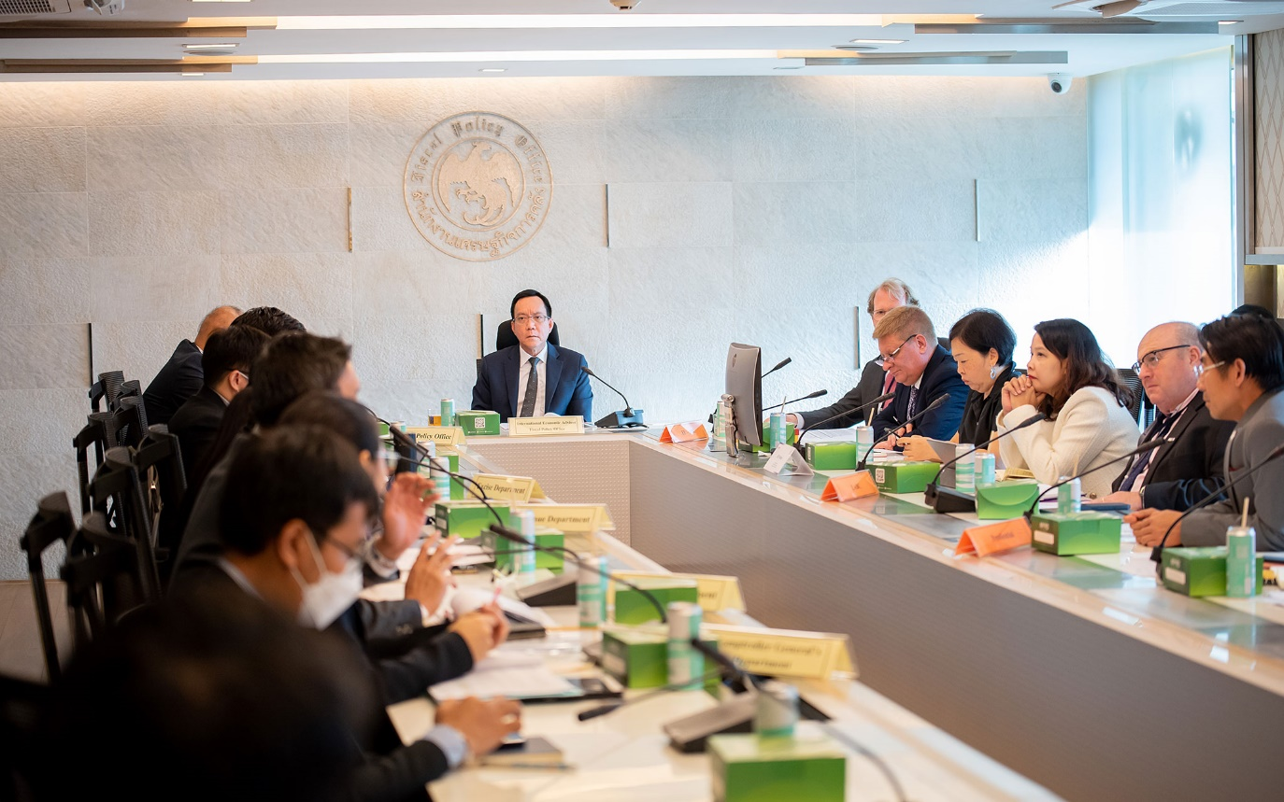
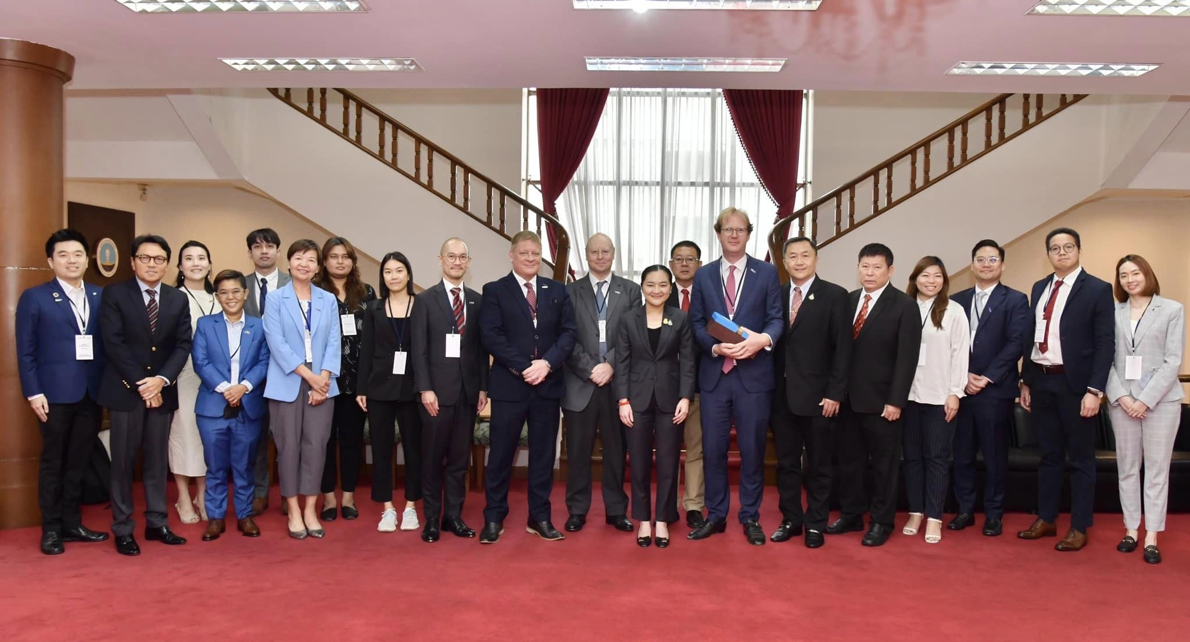
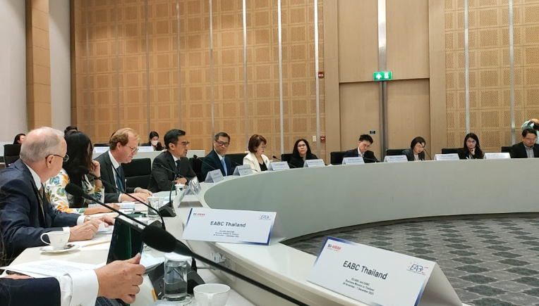
And the month was rounded off by our final ASEAN Business Mission of the year, this time to Thailand. Over 3 days in Bangkok we met 13 different Ministries and Government Agencies, with our largest ever mission to the land of Smiles. Over 90 delegates from 40 organisations took part in the Mission. Given the new government in Thailand it was an opportune time for us to go there to meet in the new Ministers and to get updates on policy direction and developments in the country. With the first round of FTA negotiations between the EU and Thailand recently completed, and a further round scheduled for early 2024, it was also important that we demonstrate the commitment of EU businesses to Thailand.
And now we are in December. Before Santa comes though we have the small matter of our final business mission of 2023 to complete – this one to Brussels where we will be meeting various Directorate-Generals of the European Commission, the EU Council, and the ASEAN Ambassadors to the EU. Beyond this packed programme, we are also organising a networking night (thank you to our Members BDO and Pernod Ricard for your kind sponsorship!) for our friends in Brussels, and a members-only briefing on the EU elections next year to look at how that will influence the EU’s position on foreign policy and trade. So yes, a very busy week in Brussels to cap off the year! Look out for the report on that business mission in our final “Notes from the ED” for 2023.
In the meantime, please keep healthy.

